Client Meeting
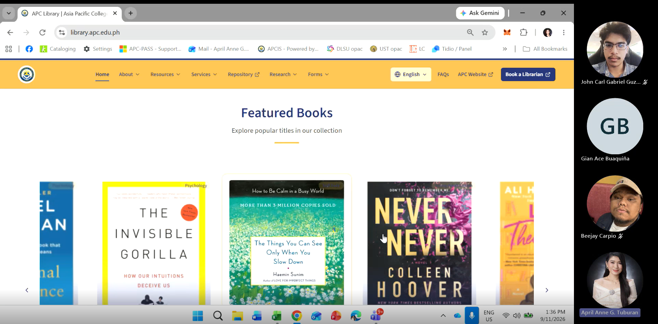

Minutes of Meeting
Date: 09-11-2026
Meeting Called By: Cache Flow
Facilitator: April Anne G. Tuburan
Link of the Meeting: Schedule a one-on-one consultation with a librarian for research assistance, citation help, database - John Carl Gabriel B. Guzman-20260911_133337-Meeting Recording.mp4

Attendees
Gian Ace Buaquiña
Beejay A. Carpio
John Carl Gabriel Guzman

Summary
The library landing page is built on a custom CMS by the IT dev team, where new arrivals and featured books are manually encoded with details like author, title, call number, and direct links to Koha. For E-books, students are redirected to Koha upon clicking, where they log in to read the book directly online; for physical books, borrowing requires visiting the library in person. Book circulation (check-ins and check-outs) is handled via Koha using barcode scanning, which automatically sends email receipts and updates to students. Students can reserve items online by setting a pickup date, which puts the item on hold in the admin dashboard to prevent double reservations. Analytics and operational reports generated by Koha (like OPAC logins, hourly foot traffic, attendance by program/school, search keywords, top borrowers, and e-book view counts) are exported to Excel processed using Power BI for accreditation compliance and collection assessment. The librarian confirmed there is currently no active chatbot on the library website and mentioned she is waiting to test the new one being developed by the team.

